Week 5 Assignment

Jessica Gurung
Westcliff University , Kings College
PRG 200
Professor Ashok
June 7, 2026

Question 1 – Bank Account Manager
I worked on a program where I made a Bank Account class. This class helps manage customer bank accounts. It stores the customers name, account number and how money they have. I added ways to put money in take money out and see how much money is there. I also made sure that you cannot take out money than you have.
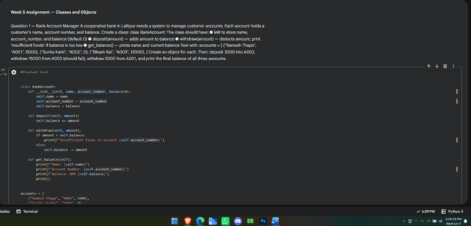
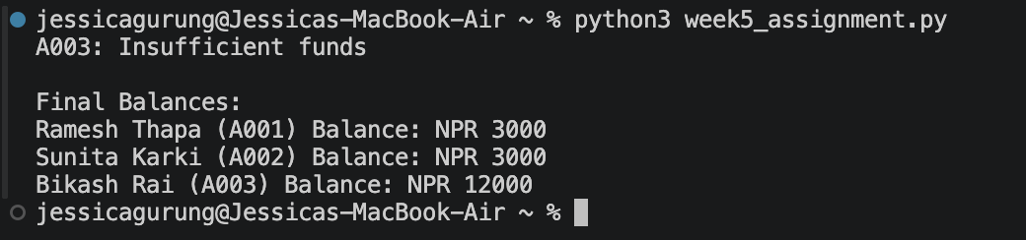

Question 2 – Student Report Card
For another program I made a Student class. This class keeps track of a students name and marks in five subjects. It calculates the marks gives a grade based on that average and says if the student passed or failed. This makes it easy to see how a student did.

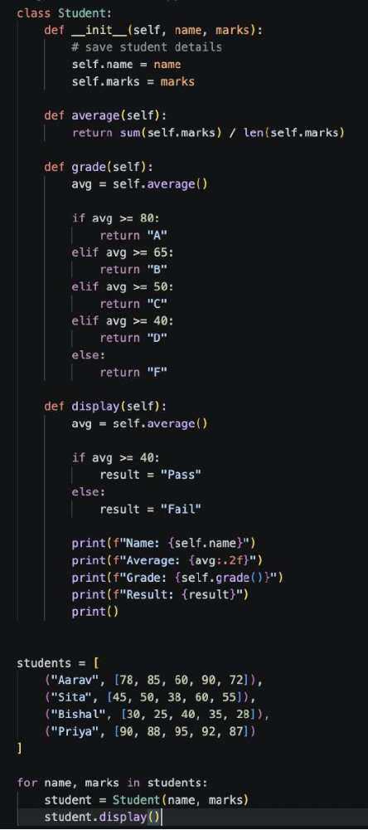
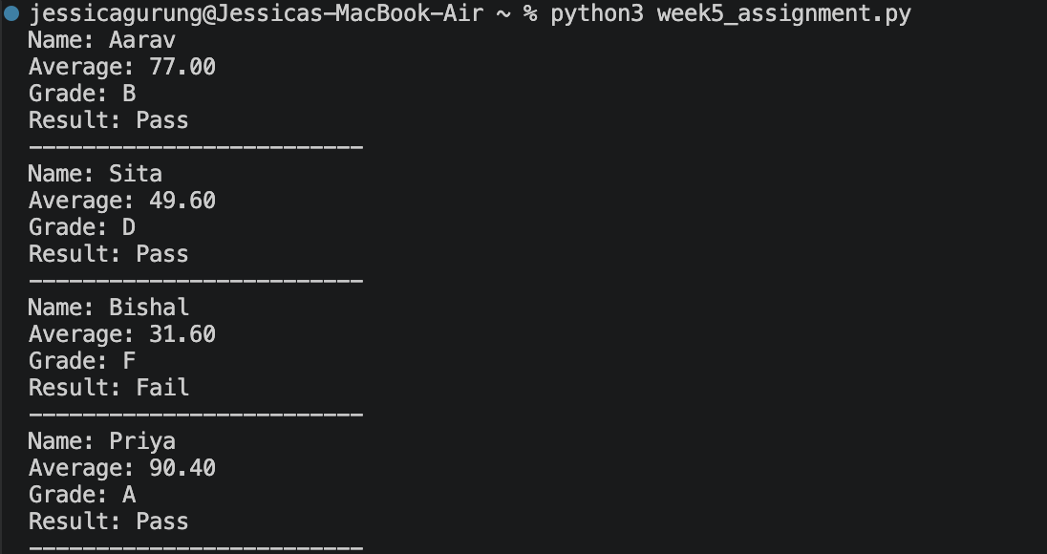

Question 3 – Food Delivery App
I also worked on a program for a food delivery app. I made a Delivery Partner class and then three more specific classes: Bike Rider, Walker and Car Driver. Each of these classes figures out how money the delivery partner makes in a different way. The program shows details about each partner. Finds out who makes the most money.
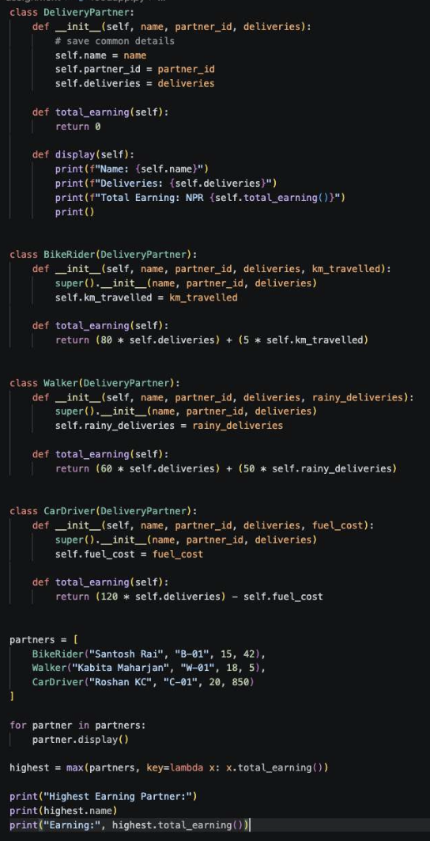

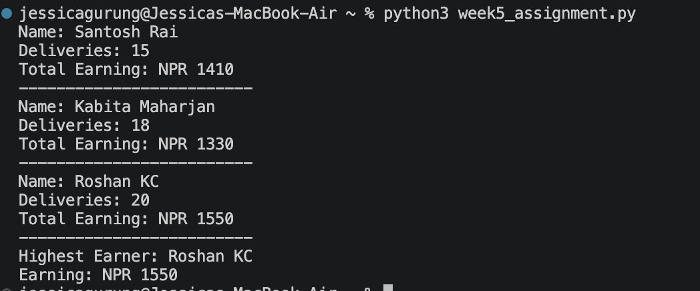

Question 4 – Bus Ticket Booking
In this program, I created a Bus class to manage seat bookings for passengers. The class checks whether a seat is already booked before confirming a reservation. It also calculates the number of available seats and displays a list of all booked passengers. This helps prevent duplicate bookings and keeps booking records organized.

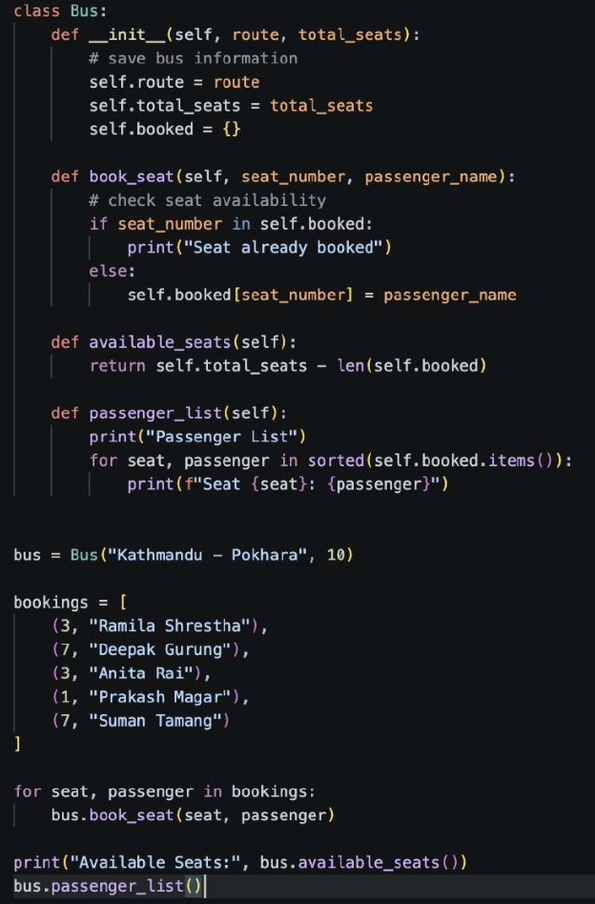
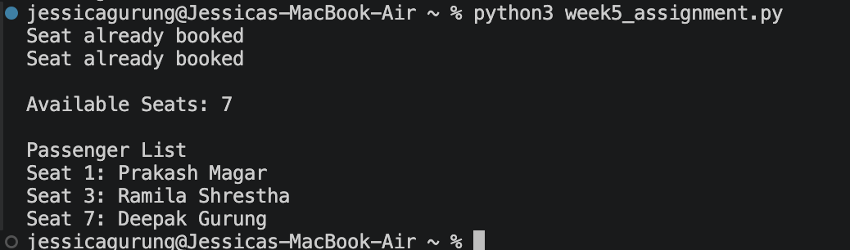

Reference
Python Software Foundation. (2024). Python documentation
https://docs.python.org/3/
Sweigart, A. (2023). Automate the boring stuff with Python (3rd ed.). No Starch Press.
https://automatetheboringstuff.com/

